**Disaster Reporting and Information Management System – DRIMS**

**Requirement Document v0.4**

**Prepared by**

Velocity Software Solutions Pvt. Ltd.   
Website: www.velsof.com,   
E-mail: inquiry@ velsof.com, nsrivastava2@ velsof.com   
E-23, Sector-63, Noida. Phone: +91-120-4243310, +91-981 032 8089

**Contents**

**1.0 Introduction** 3

**2. Dashboard to track the registration process.** 3

**2.1 State-Level Dashboard** 4

**2.2 Dashboard for District Users.** 7

**2.3 Dashboard for FO-Users** 8

**2.4 Admin Control over DFR** 9

# **1.0 Introduction**

The DRIMS has a web portal and mobile application to enable daily reporting by Revenue Circle Offices and District Disaster Management Authorities and compilation at the state level. The web-based system enables online approval at the Revenue Circle, District, and State level by appropriate authorities reducing operational delays.

# **2. Dashboard to track the registration process.**

As requested by the client a new feature was developed to register the camp inmates who take shelter in the relief camps & the non-camp inmates to whom relief materials are been distributed through relief distribution centres.

Therefore developing a UI or dashboard is required so that it becomes easy for the users at the district and state level to track which the RC has reported count in the daily flood report for camp & non camp inmates but has not provided/uploaded registration of the affected population who came to take shelter in the camp or to take GR from the relief distribution centre.

To track the registration process a dynamic dashboard needs to be developed. This dashboard will help the users to find how many Districts have completed the registration process.

Two separate dashboards shall be developed to track the registration of both camp inmates and non-camp inmates respectively.

## **2.1 State-Level Dashboard**

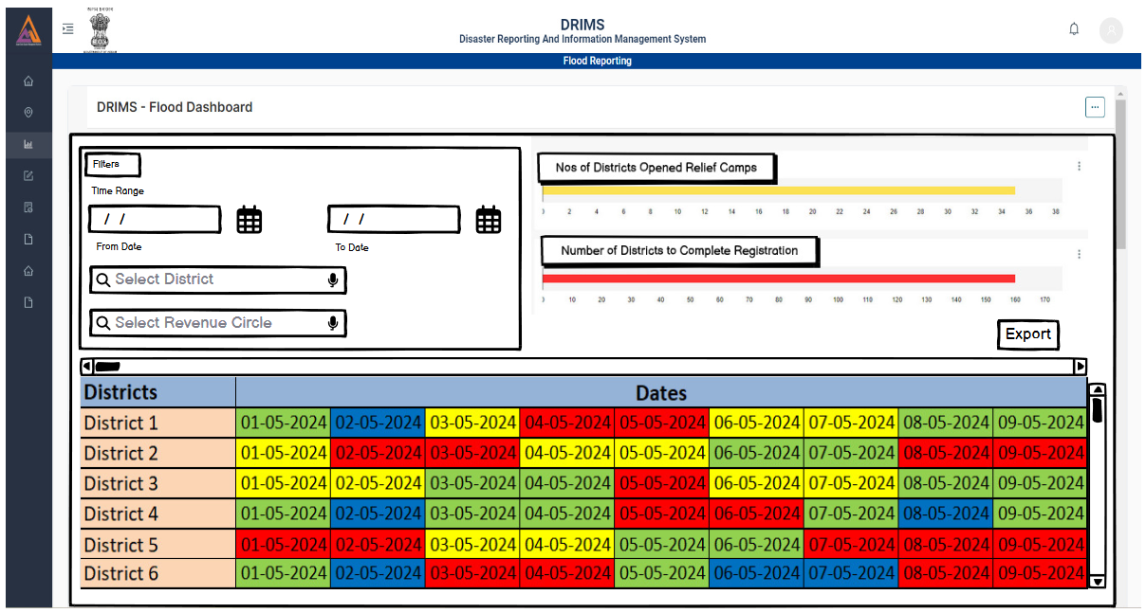

A state user will be able to check whether all the districts have completed their respective registration based on the dates. Users will be able to filter the dates to check the status for any specific period.

Here dates will be labeled with different colors based on their status, such as :

1. Green will indicate Completed.
2. Yellow will indicate partially completed.
3. Red will indicate that registration has not started yet.
4. Blue indicates that on that date there are no inmates/non-inmates in that District.

Users will be able to export Excel/CSV from here for complete details. Formats of the exported Excel/CSV will be provided along with the required document.

Users will be able to filter the dashboard based on the District and Revenue circle also.

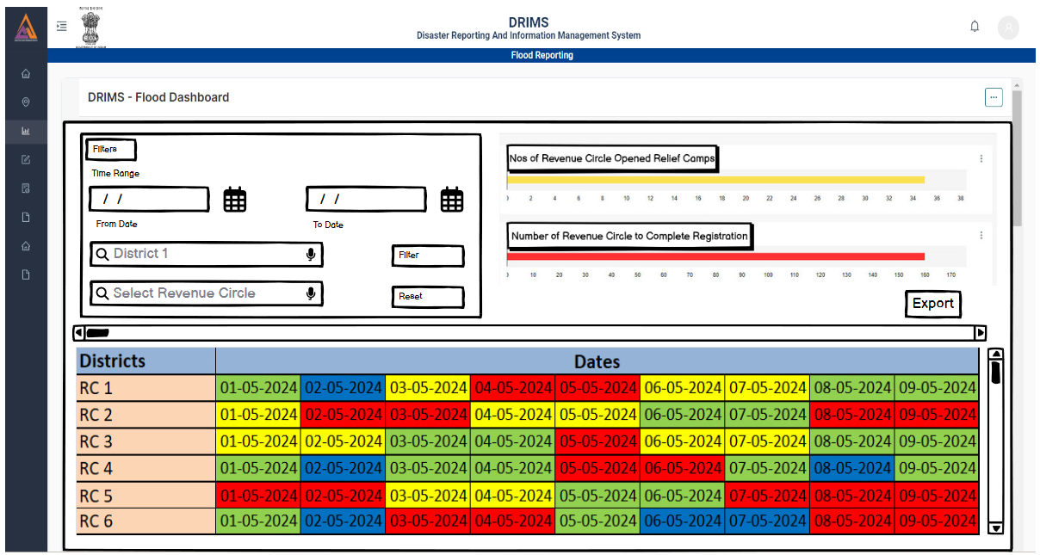

View of the dashboard if a user filters the dashboard based on District.

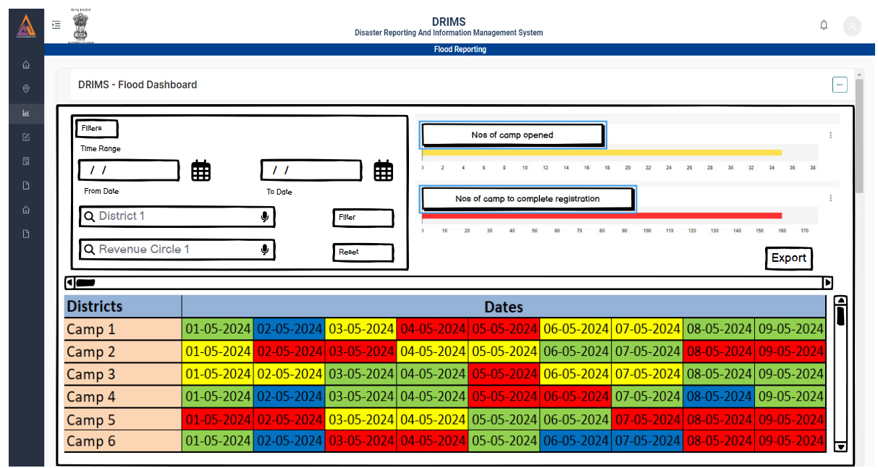

View of the dashboard if a user filters the dashboard based on district & revenue circle.

Here if a user selects any of the day system must show the number of inmates/non-camp inmates reported in that relief camp/center and the number of camp/non-camp inmates registered on that selected date.

In all the menu users will be able to export the data according to the filtered components.

## **2.2 Dashboard for District Users.**

Here users will be able to find the nos. of revenue circles of a particular district that have reported Relief Camps and nos. of revenue circles that have completed their respective registrations.

As like state users, district users will be able filter their dashboard on the bais of time & revenue circles.



A district user will be able to filter his/her dashboard based on revenue circles and time.

Further after filtering based on revenue circle, here if a user selects any of the day system must show the number of inmates/non-camp inmates reported in that relief camp/center and the number of camp/non-camp inmates registered on that selected date.

In all the menu users will be able to export the data according to the filtered components.

## **2.3 Dashboard for FO-Users**

FO-Users will be also able to use the dashboard to filter out the dates on which registration is not completed. It will help the users to know on which day how many people's registration is left out to do for which relief camps.



## **2.4 Admin Control over DFR**

A special feature needs to be developed to give special access to the admin to control the submission of the DFR.

As registration of camp inmates and non-camp inmates is mandatory client wants special access for the Admin to control the submission of DFR of the Districts.

A pop-up message needs to be displayed for the districts that have not completed the camp inmates & non-camp inmates registration process at the time of approval of District DFR.

The pop-up message will contain a confirmation message that they are submitting their report without completing the registration process and they will complete the same within 48 hours.

The system will also send SMS’s to the users as a reminder to those who have not completed the registration process.

## **2.5 Thumb Rule for calculation of Camp & Non-camp inmates** .

Currently while generating cumulative reports system is considering the highest figures of camp & non-camp inmates of a RC. Now the client wants the system to generate cumulative reports taking into consideration the highest figures of male, female, children, pregnant/lactating women, physically disabled person, big animals, small animals & poultry of camp & non-camp inmates at the camp & center level.